**LAB 5 : DATE : 16/10/23**

* **2D Arrays with Jagged Arrays:**

**INPUT:**

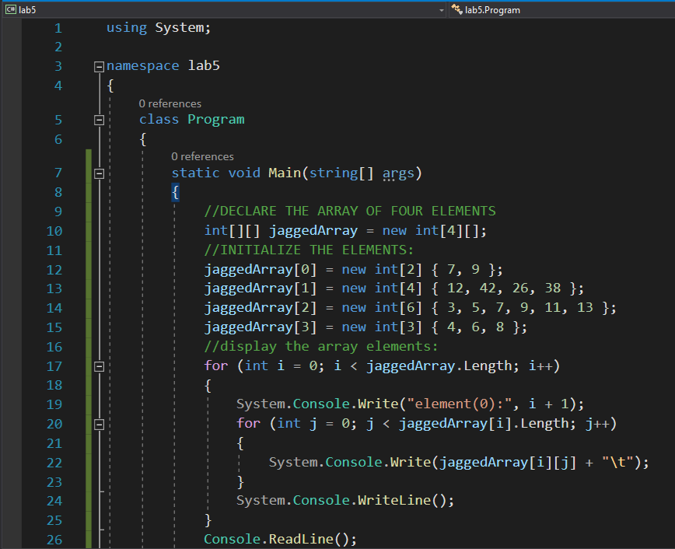

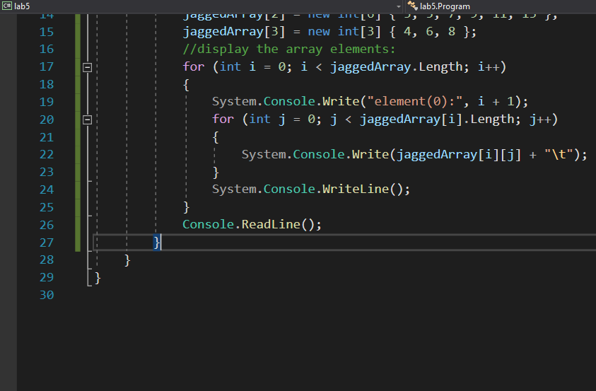

**OUTPUT:**

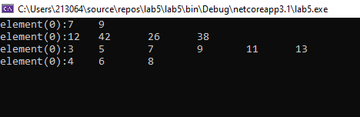

**Example01:** Create single-dimensional array and print it using for each loop.

**Code :**

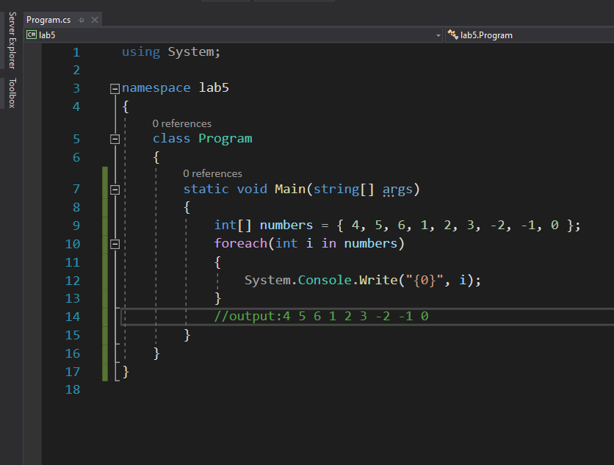

**Output :**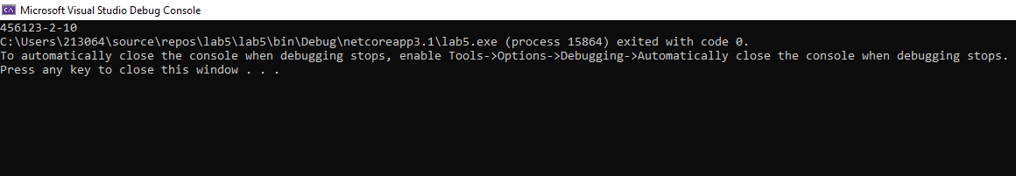

**Example 02:** Creates an array called numbers and iterates through it with the for each statement.

**Code:**

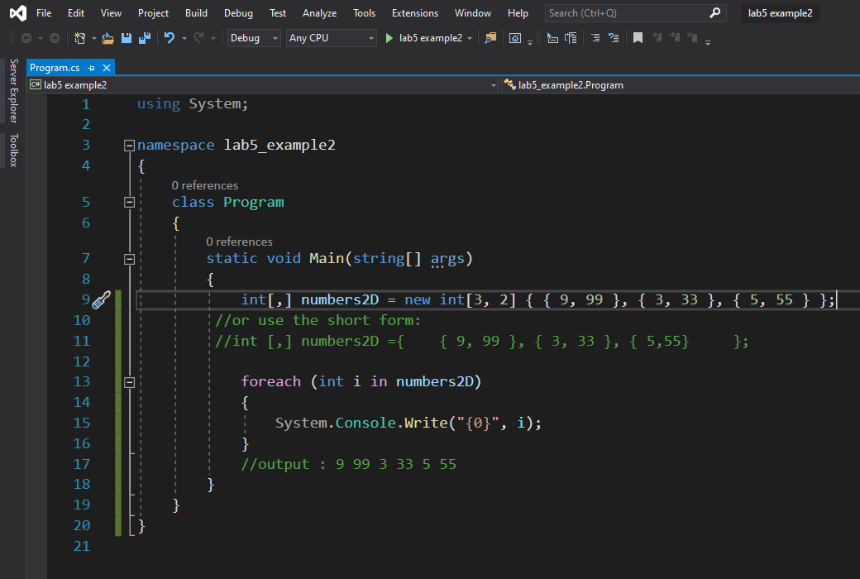

**Output:**

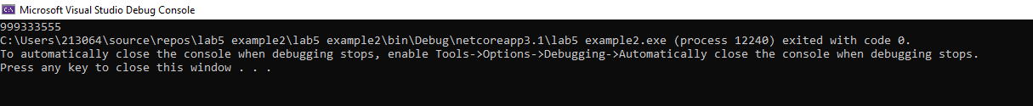

**Example 03:** Create single-dimensional, multidimensional, and jagged arrays.

**Code:**

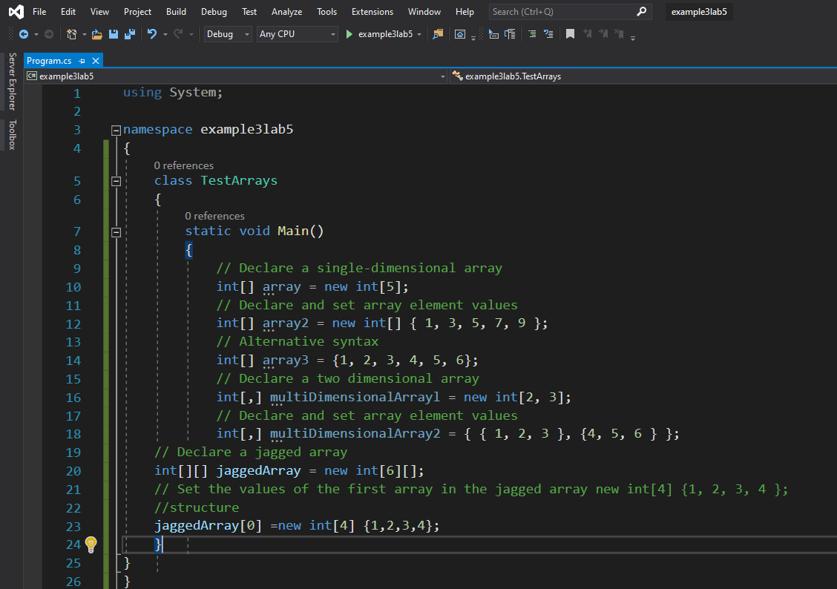

**Output :**

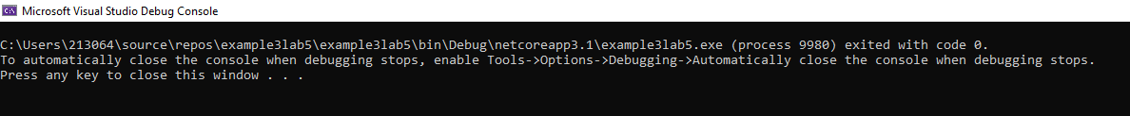

**Example 04:** Initialize an array of strings which represents days of week (i.e. Sun, Mon, Tue ... Sat) and pass as an argument to a PrintArray. The method displays the elements of the array. Create methods ChangeArray and ChangeArrayElement change the array elements. ChangeArray method reverse the array elements so that Sat comes a 0 index. ChangeArrayElement method changes the first three index of the array so that Sat comes at 0 index, Fri comes at 1st index and Thu comes at 2nd index:

**Code:**

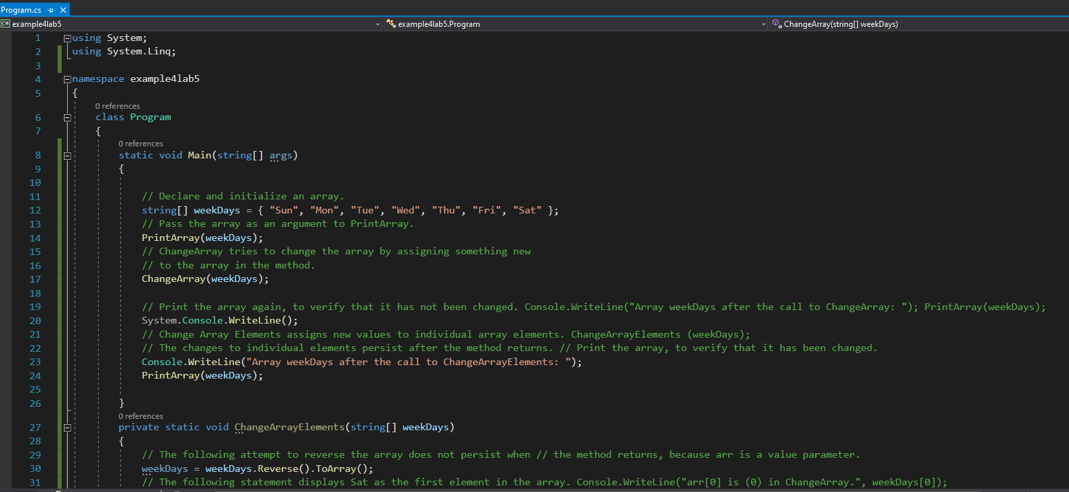

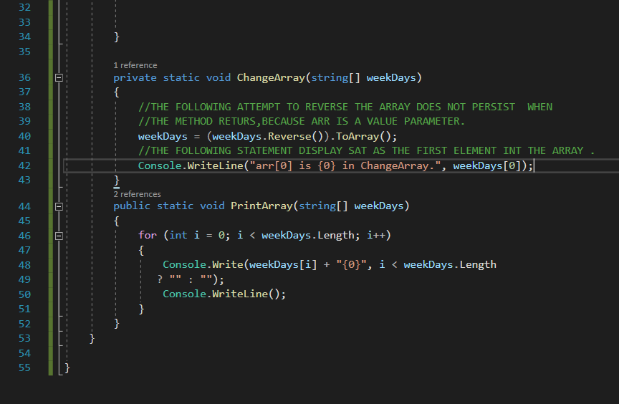

**Output:**

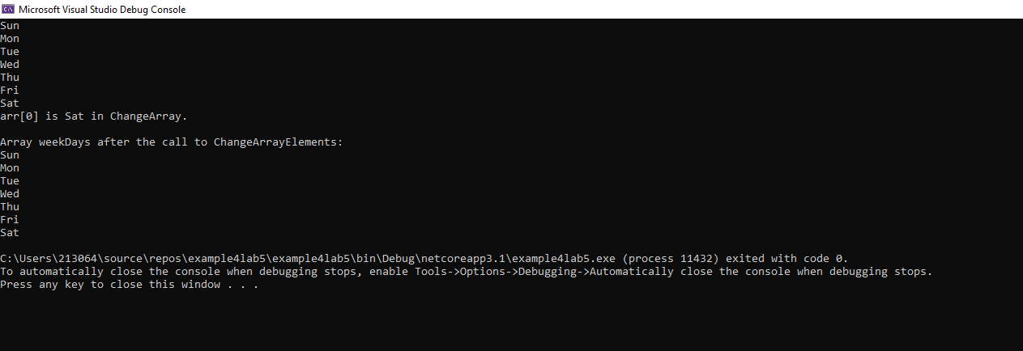

**Example 05:** Build an array whose elements are themselves arrays (Jagged array). Each one of the array elements has a different size. After creating jagged array, display array elements.